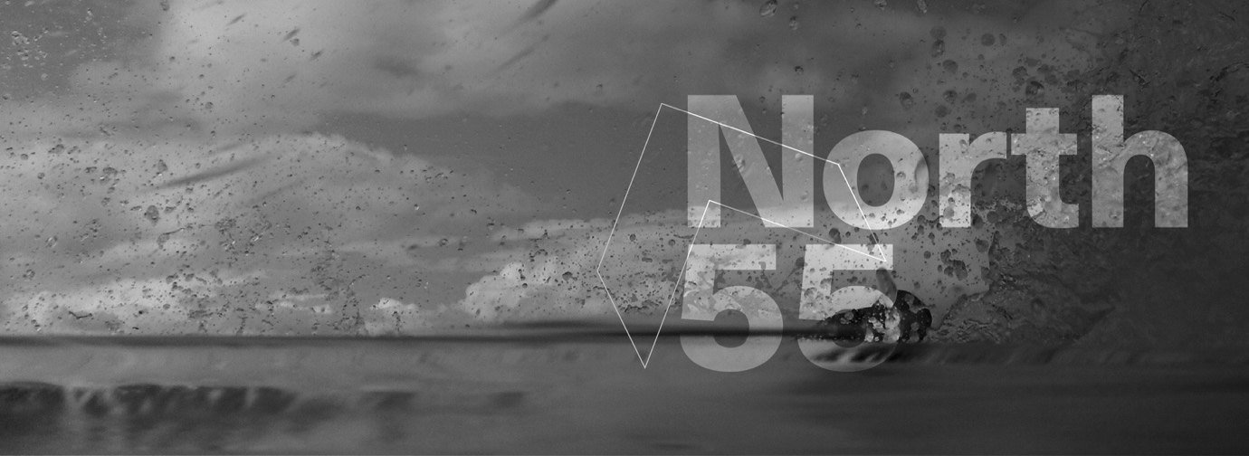

Lessons in engagement from District Six Museum and North-55
District Six Museum and North-55 are two organisations on opposite sides of the globe which have been drawn to each other’s work because of synergies in methodologies and approaches. The work of both these organisations have been inspired by geographies and landscapes, and by the people who inhabit them. In the case of District Six, such inhabitation is both residential and imaginative, as some of the people who have a close association with these places no longer live there because they were displaced from their homes. However, they continue to have a strong association with the place. Others have resumed their interrupted relationship with the land having been awarded a home as part of South Africa’s restitution process.
The importance of locality is emphasised in the way in which both of these have been named: District Six describes a place in Cape Town, South Africa which was destroyed under Apartheid and which for the most past is an imagined landscape soon to be reconstructed; North-55 calls attention to the physical location of its main site of engagement – Ireland – by using its place in the world, its line of latitude, as its name.
The District Six Museum emerged from a movement focused on supporting the community’s right to claim their loss of right in land, and on the belief that the right to remember was an important part of both the process to make a claim to the land as well as to reconstruct the spirit and ‘sense of place’ within the returning community.
Most of the Museum’s programmes with the now elderly former residents of District Six together with a new generation of young people, involves site engagements of some kind. They include walks of remembrance, site-specific art installations and performances, in situ oral histories and storytelling, reminiscing through playing traditional games at sites which were former playgrounds, and engaging in rituals of remembrance that have emerged over time. Moving through the physical space and immersing those who have less of a connection to the actual site, in such activities has proven to be a powerful pedagogical tool. I am reminded of the words of one of the young people reflecting on one a project which required her to engage with a specific site, its documentary and photographic archive and the people associated with that site: ‘never again will I walk past a vacant spot and think of it as empty. Places have come alive to me through listening to the stories of people who lived, worked or played here.’
Like North-55, District Six Museum emphasises visuality and engages with the transformative possibilities of visual art. Recent projects such as Latitude and earlier projects such as Borderland, Testimonies of the River and Landmarks are some wonderful North-55 examples of such methods of using visual art as both process work to build community ownership and knowledge, as well as to develop a tangible product.
A past District Six example was a large-scale Public Sculpture Festival which was held on the vacant land in 1997 and some of its impact continues to resonate in the present. The Festival was intended as the last statement on the land before the construction work linked to restitution was to start. The closing date for land claims was 1998, and it was anticipated that building would commence very soon after, and that a much altered and re-contoured landscape would yet again be the result. Artists were invited to submit proposals for interpreting the archive on the vacant landscape which had been identified for restitution. The intended ephemerality of the installations was to mirror the fragility of the community’s connection to the land from which they were displaced. One day they were there; the next they were gone. The remnants of the installations were to be the reminders of that uncertainty; their eventual disappearance was to recall the displacement of the community.
Both organisations intentionally choose to engage with artists who can also be facilitators and team-builders, and who can work with community members who are not necessarily artists but with thoughtful facilitation, can be artistically engaged. This is a special skill and a deliberate choice to move artistic creation out of the realm of being individually curated in specific contexts, and to honour the knowledge and expertise that people bring from different areas of work and life and which can be invaluable in the creation of meaning.
‘And the land remembers your history and the histories of all that came before you; and of its own devastation.’
Painful memories do not go away if suppressed or ignored. In our remembering we do not wish for vengeful solutions based on pains inflicted in the past. Instead, we strive to continually explore ways in which to translate past experiences of devastation into positive inspirations which foreground resilience and build hope. We have experienced the wonderful creativity that has emerged from the interplay between people, landscape and artistic intervention, and believe that herein lies some clues to our indivisible hopeful futures.

Bonita Bennett
Director District Six Museum

District Six was a vibrant and culturally diverse inner-city neighbourhood in Cape Town, South Africa, which was destroyed under Apartheid to make way for a white neighbourhood (which never materialised). All residents were racially classified and assigned to various areas of the city based on the racialised identities assigned to them by the Apartheid government. This was done under the provisions of the Population Registration and the Group Areas Acts, amongst others.
‘Apartheid’ was the name given to the system of government in South Africa, which was based on the Nationalist Party’s ideology of racial classification and segregation when it came to power in 1948.
The Land Restitution Act (1995) of the new democratic South African government, has made it possible for people to submit a formal legal claim to government for restitution for their loss of land rights under Apartheid.
See www.north-55 com for more information.
Bedford, E. and T. Munnik. Remembering that place: public projects in District Six in The District Six Public Sculpture Project. Edited by Crain Soudien and Renate Meyer

